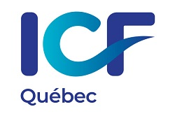

ICF Québec Convention
May 13-14, 2021
Refund policy

ICF Québec understands that particular circumstances may lead a participant to cancel their registration for an event. ICF Québec has therefore instituted a refund policy for this purpose.
Refund terms
Until April 15th: A $50 administrative fee will apply.
From April 16th to May 7th: A $75 administrative fee will apply.
After May 8th: Refund requests will not be accepted after this date. No refunds will be granted, except for medical reasons, in which case medical documentary proof must be provided.
Registration transfer
A participant who is unable to attend the Convention may transfer their registration to another participant. They must email their transfer request by May 7, 2021, to à gestion@icfquebec.org.
Transfers from an ICF Québec member to an ICF member or non-member are accepted. The new participant will be responsible for paying the cost adjustment. No penalty will be applied when transferring a registration from one ICF Québec member to another.

